**Lab Report 07**

In this lab, I am tasked with adding two matrices of equal dimensions together. I am to ensure that the matrices have equal dimensions and to add their values together.

To do this, I will utilize a while statement to validate the dimensions of the matrices and then add the input values of the matrix together using for loops.

In this instance, the values of the matrices were added because the dimensions of the second matched those of the first.

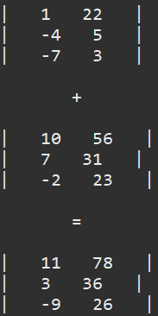

If the dimensions of both matrices do not match, the user will be prompted to reenter the dimensions of the second matrix.

This lab served to familiarize me with multi-dimensional arrays, how to utilize them, and how they are useful in my coding. I also learned what the proper implementation methods are for them to do what I want in my programs.

Additional Questions

1. What is a ragged array? An array where the dimensions are not of equal length
2. Write a code snippet to compare the equality of 2 arrays as shown below:

int[] arrayA = new int[10];

int[] arrayB = new int[10];

// write your code here

// to accept values and check if both arrays are equal

